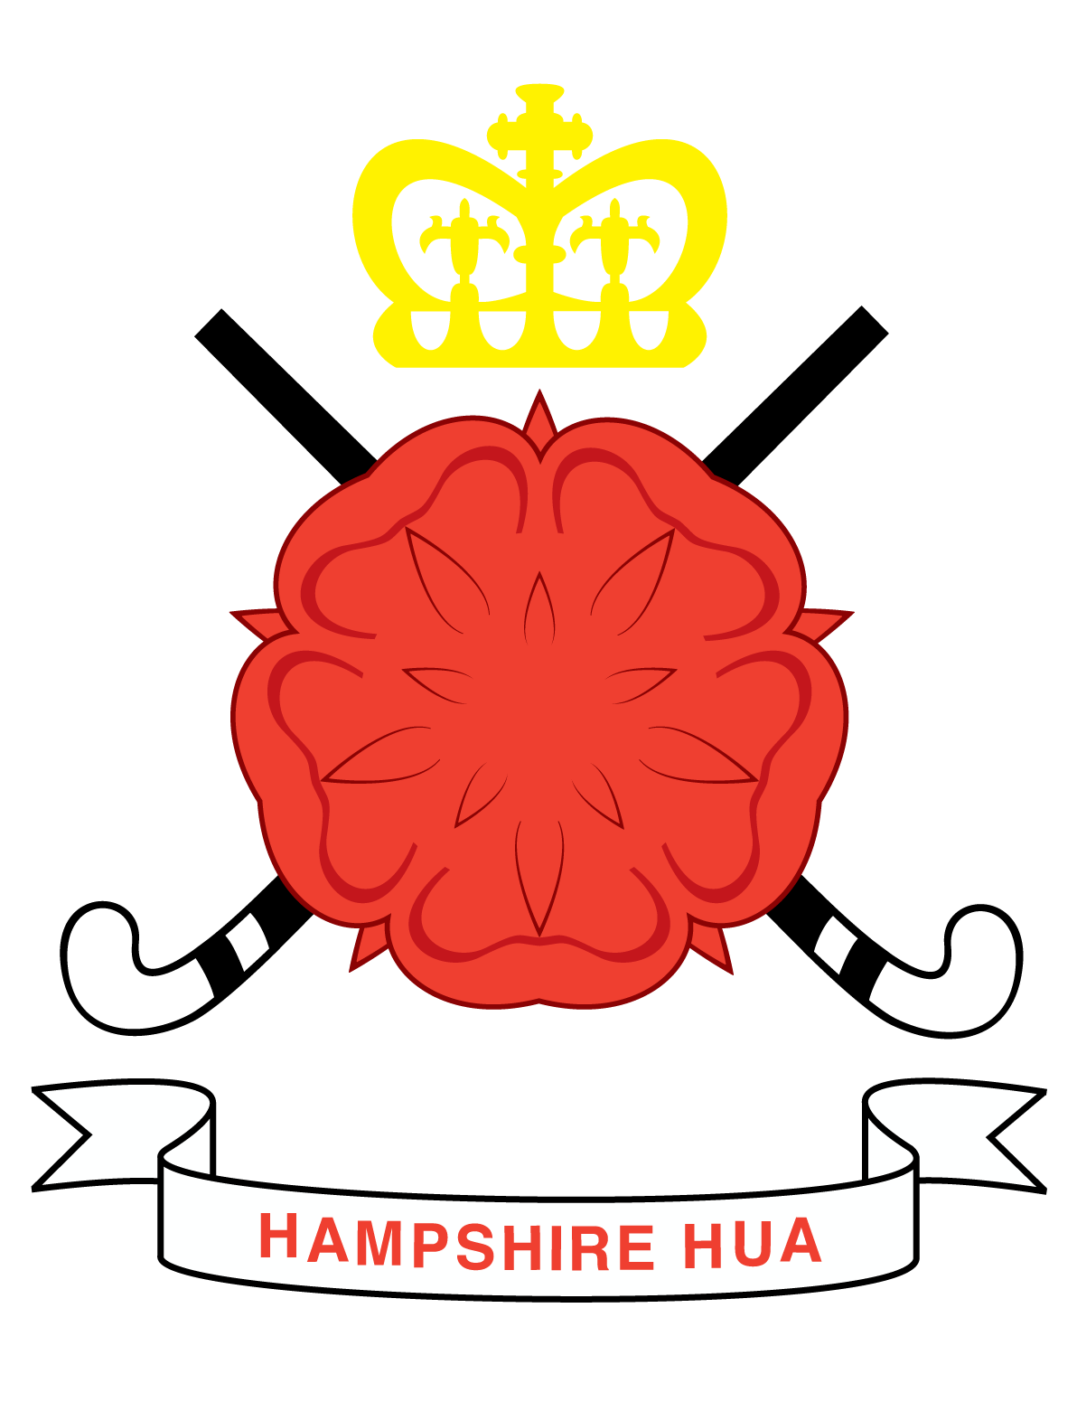
Who to Contact?
If you are interested in becoming a member of Hampshire Hockey Umpires Association, here are the important contact details:

Development Manager - If you are interested in completing the Level One Umpires Award contact the Development Manager for details.
Steve Godwin - (Home) 01489885372 (mob) 07799644230 steve.godwin@portbfs.co.uk
Youth Development Manager - If you are under 18 please contact the Youth Development Manager who can advise you.
Jason Horne - 07982 715325 jason.horne@virgin.net

Membership Secretary - If you have any queries regarding membership.
Jo Gordon - 07753865736 membershipsecretary@hampshirehockeyassociation.co.uk

